ANNEX B
2012 NJC H2 Maths Preliminary Examination Paper 2

Qn/No | Topic Set | Answers
1 | Complex Numbers | (a) (i) 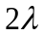  (ii) 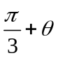  (b) (ii) 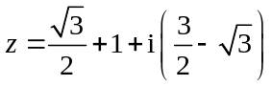
2 | Differentiation and its Applications | (a) –41.1 km/h
3 | Integration Techniques | (a) 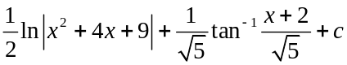  (b) 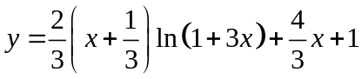
4 | Applications of Integration | (ii) 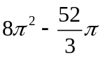
5 | Sampling Methods | (i) Randomly select a starting point in the first 50 concert goers in the queue and then pick every 50th concert goer thereafter.  (ii) There may not be sufficient information to categorize the audience members in relevant strata/find out the numbers of people in each strata.
6 | Correlation and Regression | (i) −0.972  (ii) As x increases, y decreases at an increasing rate and (B) has r-value closest to −1, (B) is the best model.  (iii) Since x = 3.8 is within the data range given, and r-value indicates a strong negative linear correlation between y and x², the estimate is reliable.
7 | Permutation & Combination | (a) (i) 10080  (ii) 9360  (iii) 720  (b) (i) 432  (ii) 735
8 | Probabilities | (i) 0.25  (ii) 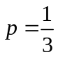  (iii) or 0.111  (iv) 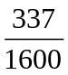 or 0.211
9 | Hypothesis Testing | (i) p-value = 0.0680407  There is insufficient evidence at 5% level of significance level to claim that the new training method has improved Kelly’s performance.  The probability of rejecting the claim that the new method has not improved Kelly’s performance when it is actually true is 0.05.  (ii) 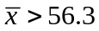
10 | Normal Distribution | (i) 0.0227  (ii) µ = 120  (iii) 0.0749  (iv) 0.322
11 | Binomial & Poisson Distribution | (a) (ii) 0.818  (b) 21  (c) 0.295  (d)  (i) The probability that one of the courts is booked will be affected by the event that another court is booked. Hence the trials do not occur independently (the probability of a court booked is not consistent) and so a binomial model would probably not be valid.  (ii) As people have to work during weekdays, the average number of demands will be fewer on the weekdays. Hence the mean on the weekday is different from that on a weekend.

